FIRST QUARTER TEST IN E.P.P.6
NAME:__________________________ DATE:___________________
GRADE and SECTION:_______________ TEACHER:________________
I. A. Systematic and Scientific Ways of Caring for Seedlings, Trees and Fruit Trees. Complete the sentences. Choose the letter of the correct answer.
1._____ is the plan showing the arrangement of plants.
a. orchard layout b. nutrient management c. building plan d. soil analysis
2. _____ is a pest that causes the leaves of trees to blister.
a. cockroach b. erinose mite c. locust d. earth worm
3._____ is using crop nutrients as efficiently as possible to improve productivity while protecting the environment.
a. building plan b. nutrient management c. soil analysis d. weeding
4. _____ ensure that a particular site does not fall outside the range of fertility considered adequate for that particular crop and soil.
a. leaf analysis b. weeding c. soil analysis d. nutrient management
5.______ is the most precise method of monitoring plant nutrient levels. While soil analysis reveals the levels of essential soil nutrients, leaf analysis shows the grower exactly what the plant has successfully absorbed.
a. soil analysis b. nutrient management c. weeding d. leaf analysis

B. Arrange the steps in young orchard management. Write correct step in the correct number.
Weeding Irrigating Fertilizing Pest Identification and Elimination Pruning
6. ______________________
7. ______________________
8. ______________________
9. ______________________
10. ______________________

II. Cultivating, Transplanting, Watering and Applying Organic Fertilizer. Write “True” if the statement is correct. If not, change the underlined words to make it correct. Choose your answer from the box.
transplanting soil dry roots wider branch

11. Operate tools safely.
12. Fill the hole with rocks.
13. Wear proper gear.
14. Cultivating is the act of caring for or raising plants.
15. Planting is the moving of plant material from one location to another.
16. Wet soils can cause the death of small roots
17. Water the leaves.
18. The fertilizer can be applied directly to the soil surface.
19. Prepare the site and the tree before you get started.
20. When digging the hole, remember – narrow is better!
III. Procedures in making organic Fertilizers and Pesticides. Write “Organic” if the material can be used to make
organic Fertilizers and Pesticides. Write “Inorganic” if the material cannot be used.
21. dried grass
22. broken ceramic plates
23. rotten meat
24. egg shells
25. paper
IV. Market Fruits and Seedlings. Write “Advantage” if the sentence is an advantage of online marketing and “Disadvantage” if not.
26. Online marketing allows you to be everywhere your clients look.
27. Viewing Problems Website downtime
28. Online marketing isn’t tied to geography or time zone.
29. Consumers Get Distracted

30. Online marketing allows you to be everywhere your clients look.

V. Variety of Fruit Trees. Identify the variety of the fruit as berries, pits, cores, citrus fruits, melons or tropical fruits.

31. honey dew

32. grapefruit

33. peach

34. apple

35. banana

36. cherry

VI. Multiple Cropping. Match Column A with Column B.
A | B
37. It is also called “polyculture”. | a. Crop Rotation
38. Growing crops one after another on a piece of land. | b. Mixed Cropping
39. A number of crops are sown and grown together during the same time on a piece of land | c. Multiple Cropping
40. Different crops are sown in separate lines one after another. | d. Relay Cropping
41. Seeds of several crops are mixed together and sown in a field | e. Line Sown Cropping
42. Each crop is cultivated in patches or strips. | f. Random Mixed Cropping
43. The successive crop is sown before the harvesting or removal of the previous crop. | g. Strip Cropping
 | h. Mixed cropping with crop of same canopy size

VII. PLAN LAYOUT FOR PLANTATION. Identify the different parts of the plan layout. Choose your answer from the box.
Parking Areas Sales barn House Shelter Building Access Lanes
Consistent Spacing Water Source

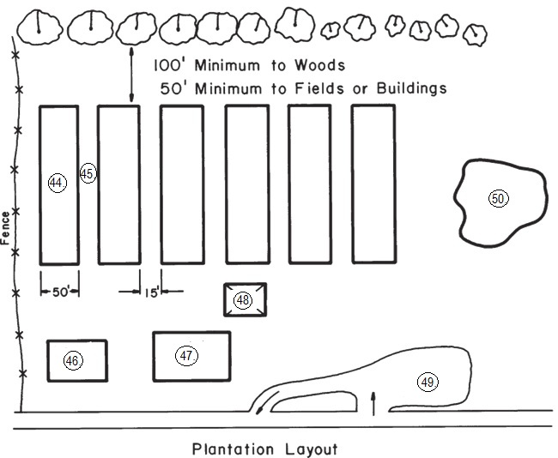

44.
45.
46.
47.
48.
49.
50.

ANSWER KEY FOR 1ST QUARTER EXAM IN EPP6
1. a
2. b
3. c
4. c
5. d
6. Fertilizing
7. Irrigating
8. Pruning
9. Pest Identification and Elimination
10. Weeding
11. true
12. soil
13.true
14. true
15.transplanting
16. dry
17. roots
18. true
19. true
20. wider
21. Organic
22. Inorganic
23. Inorganic
24. Organic
25. Organic
26. Advantage
27. Disadvantage
28. Advantage
29. Disadvantage
30. Advantage
31. melons
32. citrus
33. pits
34. core
35. tropical fruits
36. pits
37. c
38. a
39. b
40. e
41. f
42. g
43. d
44. consistent spacing
45. access lanes
46. house
47. sales barn
48. shelter building
49. parking areas
50. water source

