KINDERGARTEN  DAILY LESSON LOG | SCHOOL: | SAN ROQUE 2 ELEMENTARY SCHOOL | TEACHING DATES: | June 26-30, 2017
 | TEACHER: | CHERRIE ANN A. DELA CRUZ | WEEK NO. | WEEK 4
 | CONTENT FOCUS: | I AM UNIQUE | QUARTER: | 1ST QUARTER

PROCEDURES  (BLOCKS OF TIME) | OBJECTIVES | CONTENT
 |  | MONDAY | TUESDAY | WEDNESDAY |  |  | THURSDAY | FRIDAY
ARRIVAL TIME | Developmental domains:  Language, Literacy and Communication | Daily Routine  National Anthem  Opening Prayer  Exercise  Kamustahan  Balitaan | Daily Routine  National Anthem  Opening Prayer  Exercise  Kamustahan  Balitaan | Daily Routine  National Anthem  Opening Prayer  Exercise  Kamustahan  Balitaan |  |  | Daily Routine  National Anthem  Opening Prayer  Exercise  Kamustahan  Balitaan | Daily Routine  National Anthem  Opening Prayer  Exercise  Kamustahan  Balitaan
Content Standard
The child demonstrate an understanding of increasing his/herconversation skills
Performance Standard
The child shall be able to confidently speaks and expresses his/ her feelings and ideas in words that make sense
Learning Competency Code
LLKVPD-Ia-13,LLKOL-Ia 1-2,
LLKOL-Ig3&9, LLKOL-00-10
MEETING TIME 1 | Developmental domains:  Understanding the Physical and Natural Environment(PNE)  Life Science: Body and the Senses | Message: I have a body  My body has different parts. I can see some parts.  Questions: What are the parts of the body?  What parts of the body do you see? | Message:  I have a body  I cannot see some parts  Questions: What are the other parts of our body?  What parts of t he body can we not see? | Message: I have two hands I have 5 fingers in each hand. My hands are connected to my arms.  I can move my hands in different ways.  Questions: Are our hands all the same? How are they the same? How are they different?  Song: Lima ang Daliri |  |  | Song: Hokey Poky/ Kanang Kamay  Message: I use my hands for doing different things  Questions: Why do you think we need a pair of hands for? How hard do you think it is to live without 1 or 2 hands? | Song: I Can Do Many Things  (PEHT p. 162)  Message: I have two feet. I have five toes in each foot My feet are connected to my legs.  I can move my feet in many ways.  Questions: Are all our feet the same? How are they the same? How are they different?
Content Standard
The child demonstrates an understanding of body parts and their uses
Performance Standard
The child shall be able to take care of oneself and environment and able to solve problems encountered within the context of everyday living.
Learning Competency Code
PNEKBS-Id-1
PNEKBS-Id-2
PNEKBS-Id3
WORK PERIOD 1 | Developmental domains:  *Kalusugang Pisikal at Papapaunlad ng kakayahang Motor (Fine Motor)  * Language, Literacy and Communication | Teacher Supervised:  Balangkas ng Katawan ko  Objectives: Naipahhayag ang pagkamalikhai sa pagbakat sa papel ng bahagi ng katawan.  Natutukoy ang ibat ibang bahagi ng katawan.  Independent:  Playdough: My Body  Objective: to identify the different body pats  Activity: Trace the broken lines to form the missing body parts. Color the picture.  Assignment:  Draw a line to match each name with the correct body parts. | Teacher Supervised: Body Tracing : What’s inside our body?  Objectives: To identify the parts that is inside the body and their function.  Independent:  Name the body part  Objective: To make personal connections | Teacher Supervised:  Objective: Tracing  Independent:  Body Lotto  Objective: Body part Recognition |  |  | Teacher Supervised:  Objective: Tracing  Independent:  Body Lotto  Objective: Body part Recognition | Teacher Supervised: Foot Print  Objectives: to recognize one’s foot design  Independent  Hand Shape book  I feel with my hand  Objective: to identify things we can touch.  .
Content Standard
The child demonstrates an understanding of:
- Similarities and differences of what he/she can see
- Sarilng kakayahang sumubok, gamitin nang maayos ang kamay upang lumikha/lumimbag

Performance Standard
The child shall be able to:
- Critically observes and makes sense of things around him/her
- Kakayahang gamitin ang kamay at daliri
Learning Competency Code
KPKFM-00-1.4
KPKFM-00-1.5
LLKVPD -00-3
LLKVPD-00-5

MEETING TIME 2 | Developmental domains:  Understanding the Physical and Natural Environment(PNE)  Life Science: Body and the Senses | Ask children to name the body parts in the “ Balangkas ng Katawan”  Note: Intrduce both Englis and Filipin terms.  Song: Everybody Do this | Introduce the poem ”Inside Me”  Song: “Head, Shoulders, Knees and Toes” | Song: Reaching with my arms  Message: Wee see blue things around us.  Questions: What blue things do you see in our classroom?  Who are wearing blue? Whose favorite color is blue? |  |  | Poem: One, Two, How do you do? | Poem: One, Two, How do you do?  Recite the poem in a round.
Content Standard
The child demonstrates an understanding of body parts and their uses.

Performance Standard
The child shall be able to take care of oneself and environment and able to solve problems encountered within the context of everyday living.
Learning Competency Code
PNEKBS-Id-1
PNEKBS-Id-2
PNEKBS-Id3
SUPERVISED RECESS | Developmental domains:  Pangangalaga sa Sariling Kalusugan at Kaligtasan | SNACK TIME (Teacher Supervised)
Content Standard
Ang bata ay nagkakaroon ng pang-unawa sa kakayahang pangalagaan ang sariling kalusugan at kaligtasan
Performance Standard
Ang bawat bata ay nagpapamalas ng pagsasagawa ng mga pangunahing kasanayan ukol sa pansariling kalinisan sa pang-araw araw na pamumuhay at pangangalaga para sa sariling kaligtasan
Learning Competency Code
KPKPKK-Ih-1
NAP
STORY TIME | Developmental domains:  Book and Print Awarness | This is My Body | Nagsasabi na si Patpat  Procedure:  1. Paghahanda sa mga bata sa pakikinig ng kwento.  2. Paglalahad ng mga bagay na dapat tandaan sa pakikinig ng kuwento.  3. Pagkukuwento |  |  | Planetang Asul  Procedure:  1. Paghahanda sa mga bata sa pakikinig ng kwento.  2. Paglalahad ng mga bagay na dapat tandaan sa pakikinig ng kuwento.  3. Pagkukuwento | Si Hinlalaki  Procedure:  1. Paghahanda sa mga bata sa pakikinig ng kwento.  2. Paglalahad ng mga bagay na dapat tandaan sa pakikinig ng kuwento.  3. Pagkukuwento | I Like Me  Procedure:  1. Paghahanda sa mga bata sa pakikinig ng kwento.  2. Paglalahad ng mga bagay na dapat tandaan sa pakikinig ng kuwento.  3. Pagkukuwento
Content Standard
The child demonstrates an understanding of book familiarity awareness that there is a story to read with a beginning and an end, written by authors,illustrated with someone
Performance Standard
The shall be able to use the book handle and turn the pages take care of books, enjoy listening to stories repeatedly and may play pretend- reading and associates him/herself with the story
Learning Competency Code
LLKBPA-00-2 to 8
WORK PERIOD 2 | Developmental domains:  Mathematics | Teacher Supervised:  Height Chart: Gaano ka Katangkad  Objective: To measure height using non standard units and tools  Independent:  Number Lotto  Objective: to match numerals | Teacher Supervised  Who has more: Comparing up to quantities of 3 (2 groups only)  Objective: To compare quantities up to 3  Independent  Objective: To recognize and identify numerals |  |  | Teacher Supervised  Who has more: Comparing up to quantities of 3 (2 groups only)  Objective: To compare quantities up to 3  Independent  Comparing Number- A game for Partners  Objectives: Compares quantities | Teacher Supervised  Classification: Color  Objectives: to classify objects according to color  Independent  Comparing Number- A game for Partners  Objectives: Compares quantities | Teacher Supervised  Color Pattern  Red-Blue- Yellow  Objective: to extend and reproduce a pattern  Independent  Classification: Color  Objectives: to classify objects according to color  Other Activity: Color the objects correctly.  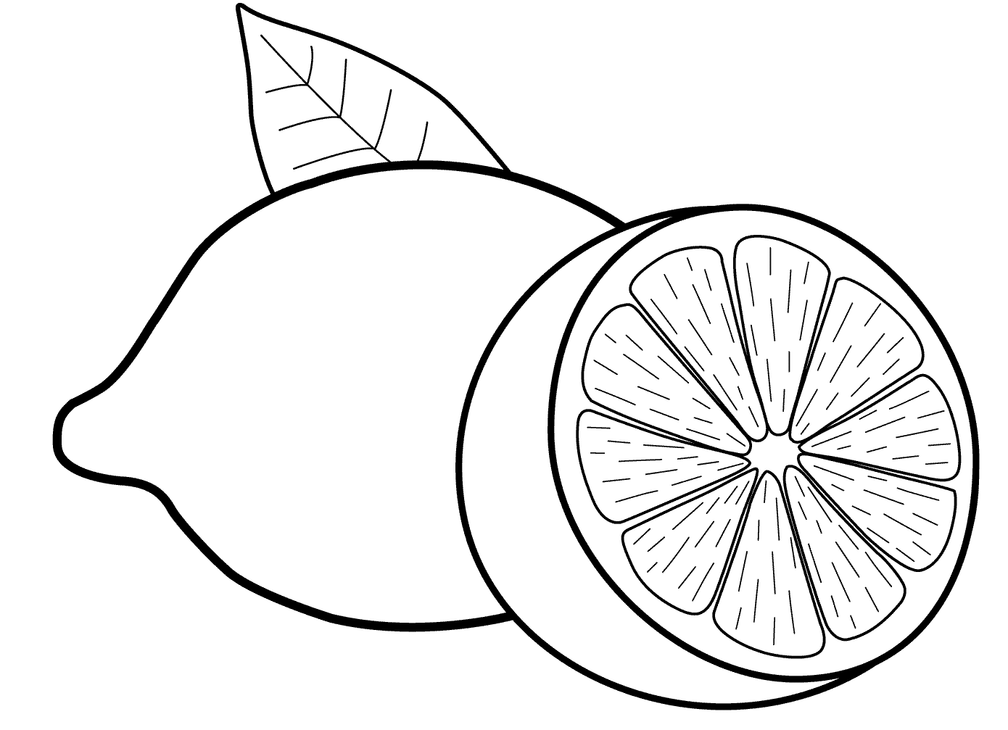
Content Standard
The child demonstrates an understanding of :
*the sense of quantity and numeral relations, that addition result in increase and subtraction results in decrease
*concepts of size length, weight, time, and money
Performance Standard
The child shall be able to *perform simple addition and subtraction of up to 10 0bjects or pictures/drawing
*use arbitrary measuring tools/means t determine the size, length, weight of things around him/her
Learning Competency Code
MKC -00 -2 TO 4
MKME-00-1
MKME-00-2
INDOOR /OUTDOOR ACTIVITIES | Developmental domains:  Kalusugang Pisikal at pagpapaunlad ng kakayahang Motor | Move that body  (PEHT p.55)  Objective: to demonstrate movement of different body parts | Sabi ni Pedro  (PEHT p.51)  Objective: to learn hear discriminately and able to follow instruction |  |  | Movement Exploration  (PEHT p.219) | Circle Blind Guess | Don’t Touch  (PEHT p.53)
Content Standard
Ang bata ay nagkakaroon ng pang-unawa sa kanyang kapaligiran at naiuugnay dito ang angkopna paggalaw ng katawan.
Performance Standard
Ang bata ay nagpapamalas ng maayos na galaw at koordinasyon ng mga bahagi ng katawan.
Learning Competency Code
KPKGM –Ia-1 to 3
MEETING TIME 3 | DISMISSAL ROUTINE
REMARKS
REFLECTION
A. No. of learners who earned 80% of the evaluation
B. No. of learners who require additional activities for remediation
C. Did the remedial lessons work? No. of learners who have caught up with the lesson.
D. No. of Learners who continue to require remediation
E. Which of my teaching strategies work well? Why did these work?
F. What difficulties did I encounter which my principal /supervisor can help me solve?
G. What innovation or localized materials did I use/discover which I wish to share with other teacher?

