 **Department of Education**

**Region III**

**Schools Division of Zambales**

**District of Palauig**

**LIPAY ELEMENTARY SCHOOL**

**FIRST QUARTERLY ASSESSMENT**

**Kindergarten**

**Name:**

**LANGUAGE**

**Box the things we do in our school.**

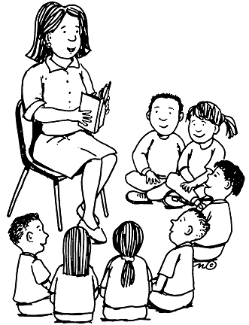

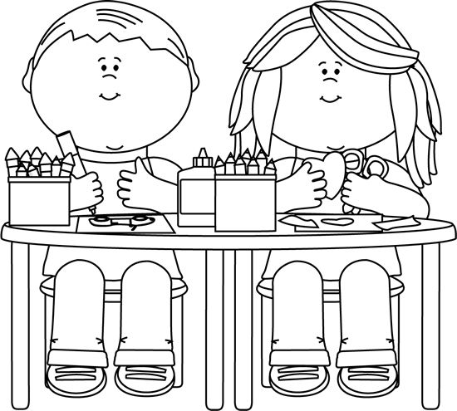

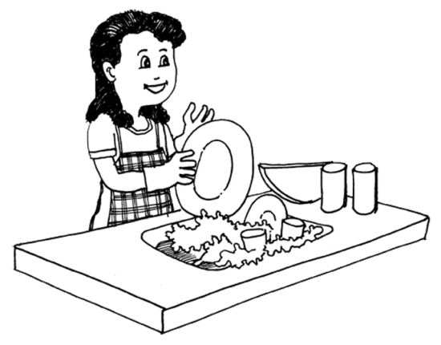

**Color the people in our school.**

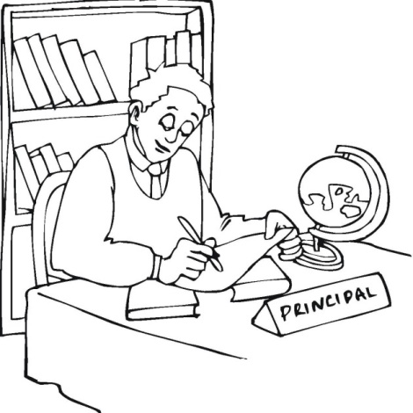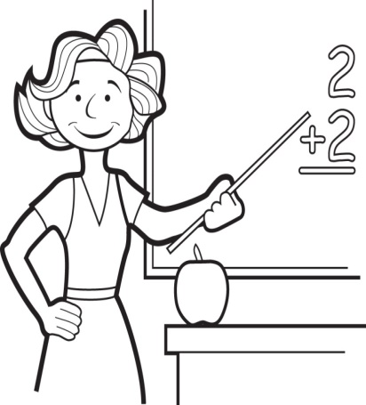

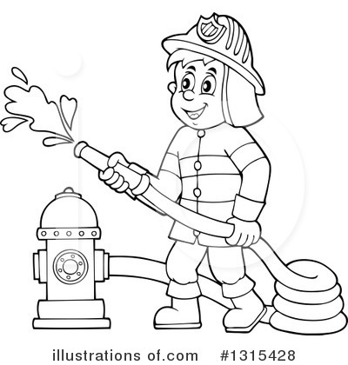

**Encircle the letter that is the same as the letter on the left box.**

d p b

b

h

u n m

r h k

n

**Color two pictures that are the same.**

|  |  |  |  |
| --- | --- | --- | --- |
| http://images.clipartpanda.com/flip-flop-clipart-black-and-white-flip-flops-md.png | http://images.clipartpanda.com/tennis-clipart-black-and-white-shoe-clip-art_1404137009.jpg | http://www.clipartkid.com/images/20/neat-socks-clip-art-at-clker-com-vector-clip-art-online-royalty-t0Ez7w-clipart.png | http://images.clipartpanda.com/tennis-clipart-black-and-white-shoe-clip-art_1404137009.jpg |

|  |  |  |  |
| --- | --- | --- | --- |
| http://niceclipart.com/wp-content/uploads/2016/03/Baseball-cap-clipart-black-and-white-2.png | http://cliparting.com/wp-content/uploads/2016/07/Beach-umbrella-clip-art-free-clipart-umbrella-outline-feebase-net.bmp | http://niceclipart.com/wp-content/uploads/2016/03/Baseball-cap-clipart-black-and-white-2.png |  |

|  |  |  |  |
| --- | --- | --- | --- |
| http://png.clipart.me/graphics/thumbs/178/chair-outline-vector-illustration_178534877.jpg | http://png.clipart.me/graphics/thumbs/178/chair-outline-vector-illustration_178534877.jpg | http://clipartsign.com/upload/2016/02/18/table-clipart-2.png | http://images.clipartpanda.com/cabinet-clipart-outline-wooden-furniture-lineart-bookcase-shelf-bookshelf_f.jpg |

**FILIPINO**

**Kulayan ang magkakatulad.**

|  |  |  |  |
| --- | --- | --- | --- |
| lollipop | candy-coloring-page | lollipop | lollipop |
| Preschool-Apple-Coloring-Pages | Preschool-Apple-Coloring-Pages | clipart watermelon | Preschool-Apple-Coloring-Pages |
| images (17) | images (35) | images (35) | images (35) |

**Lagyan ng ekis (x) ang naiibang letra sa hanay.**

|  |
| --- |
| n m m m |
| a a e a |
| r s r r |
| i i i o |

**Pagkabitin ang mga bagay na magkaugnay.**





**NUMERACY**

**Kulayan ang iba’t- ibang hugis sa ibaba na naaayon sa kulay na**

**babanggitin ng guro.**

**bilog - (berde) tatsulok - (pula)**

**parisukat - (asul) parihaba - (dilaw)**

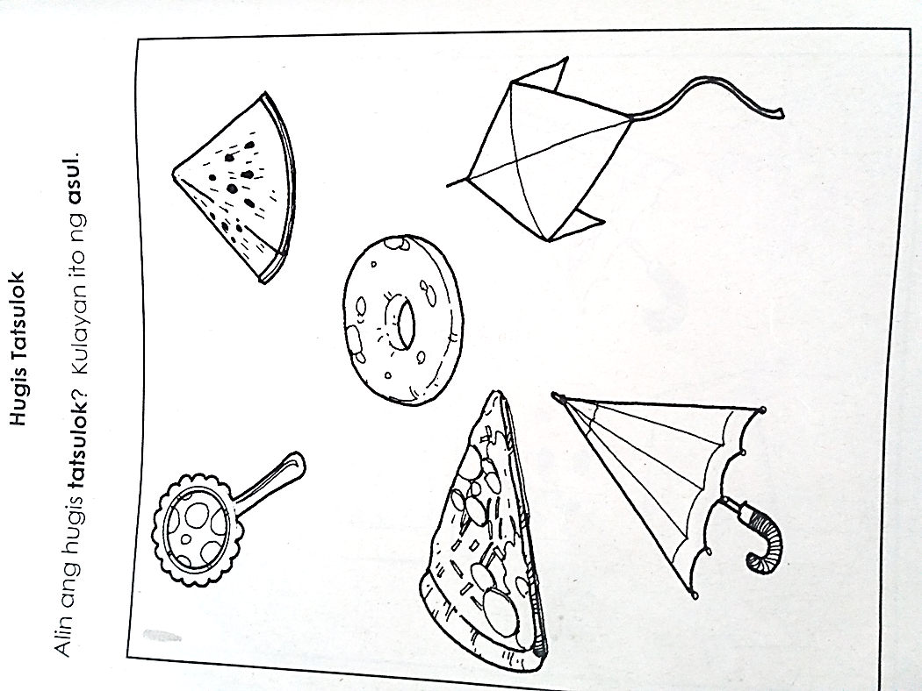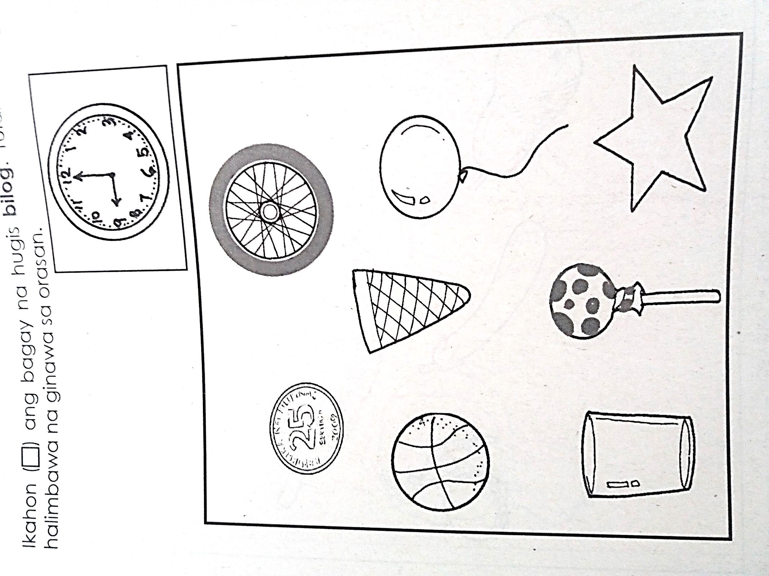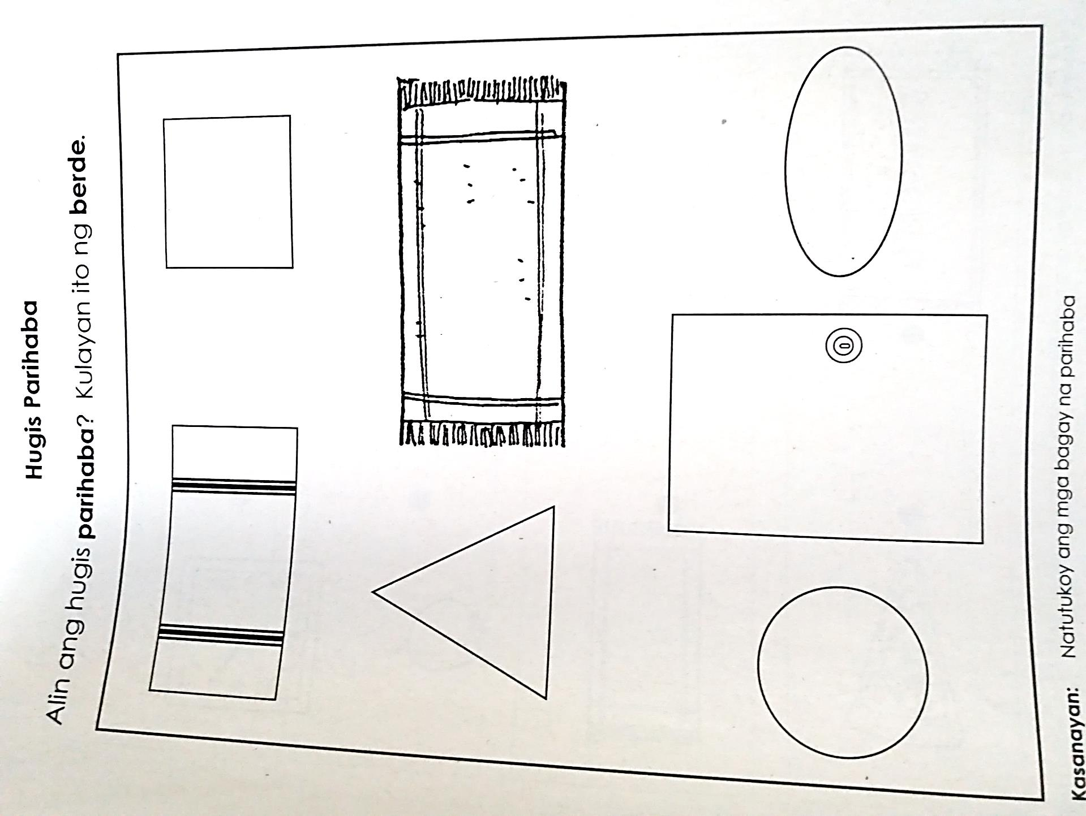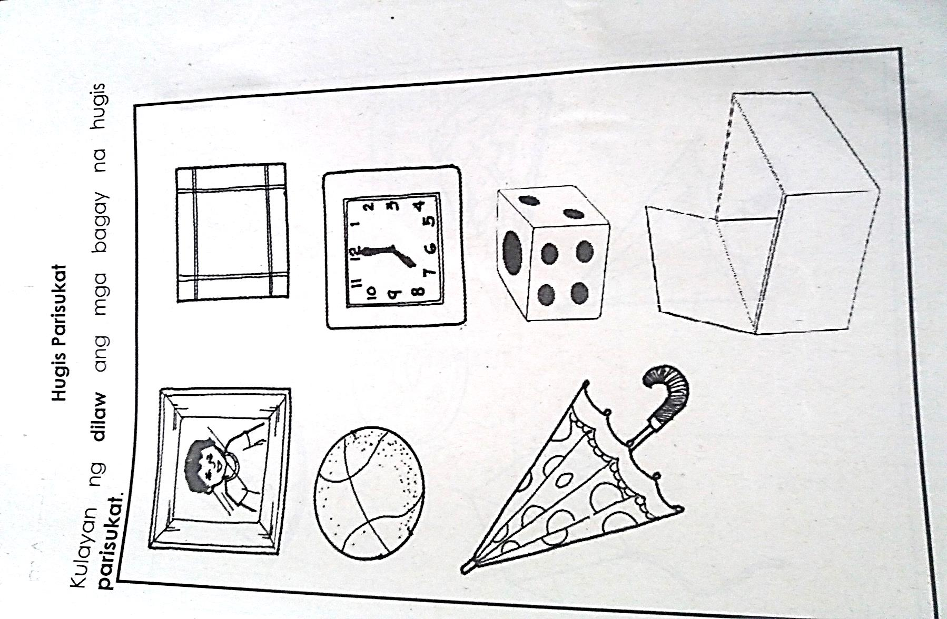

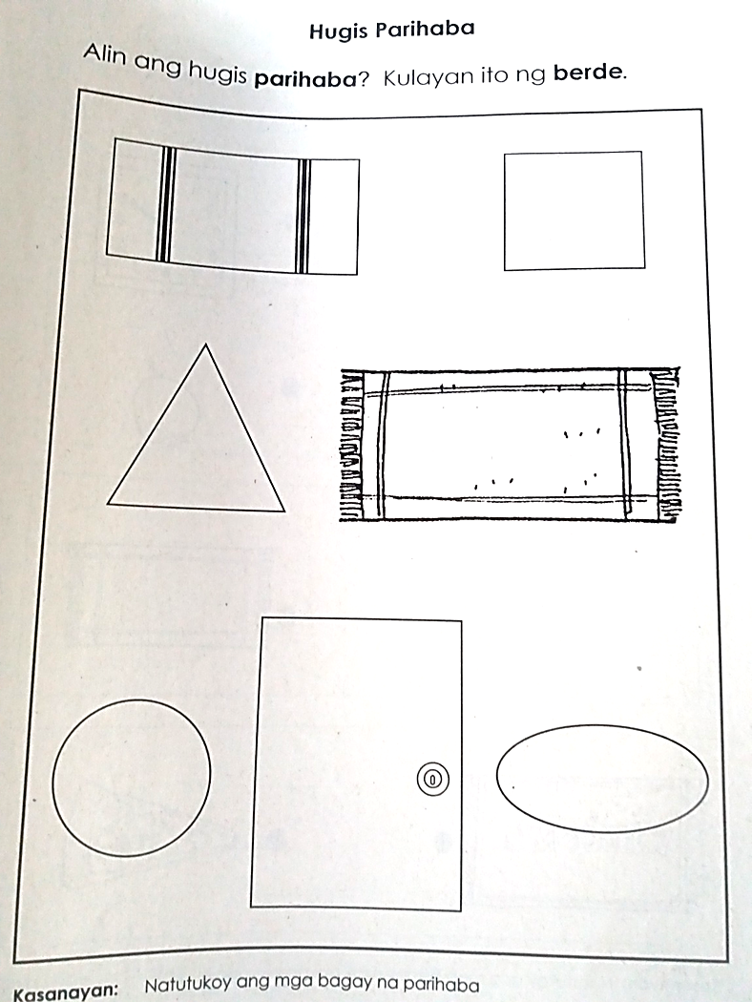

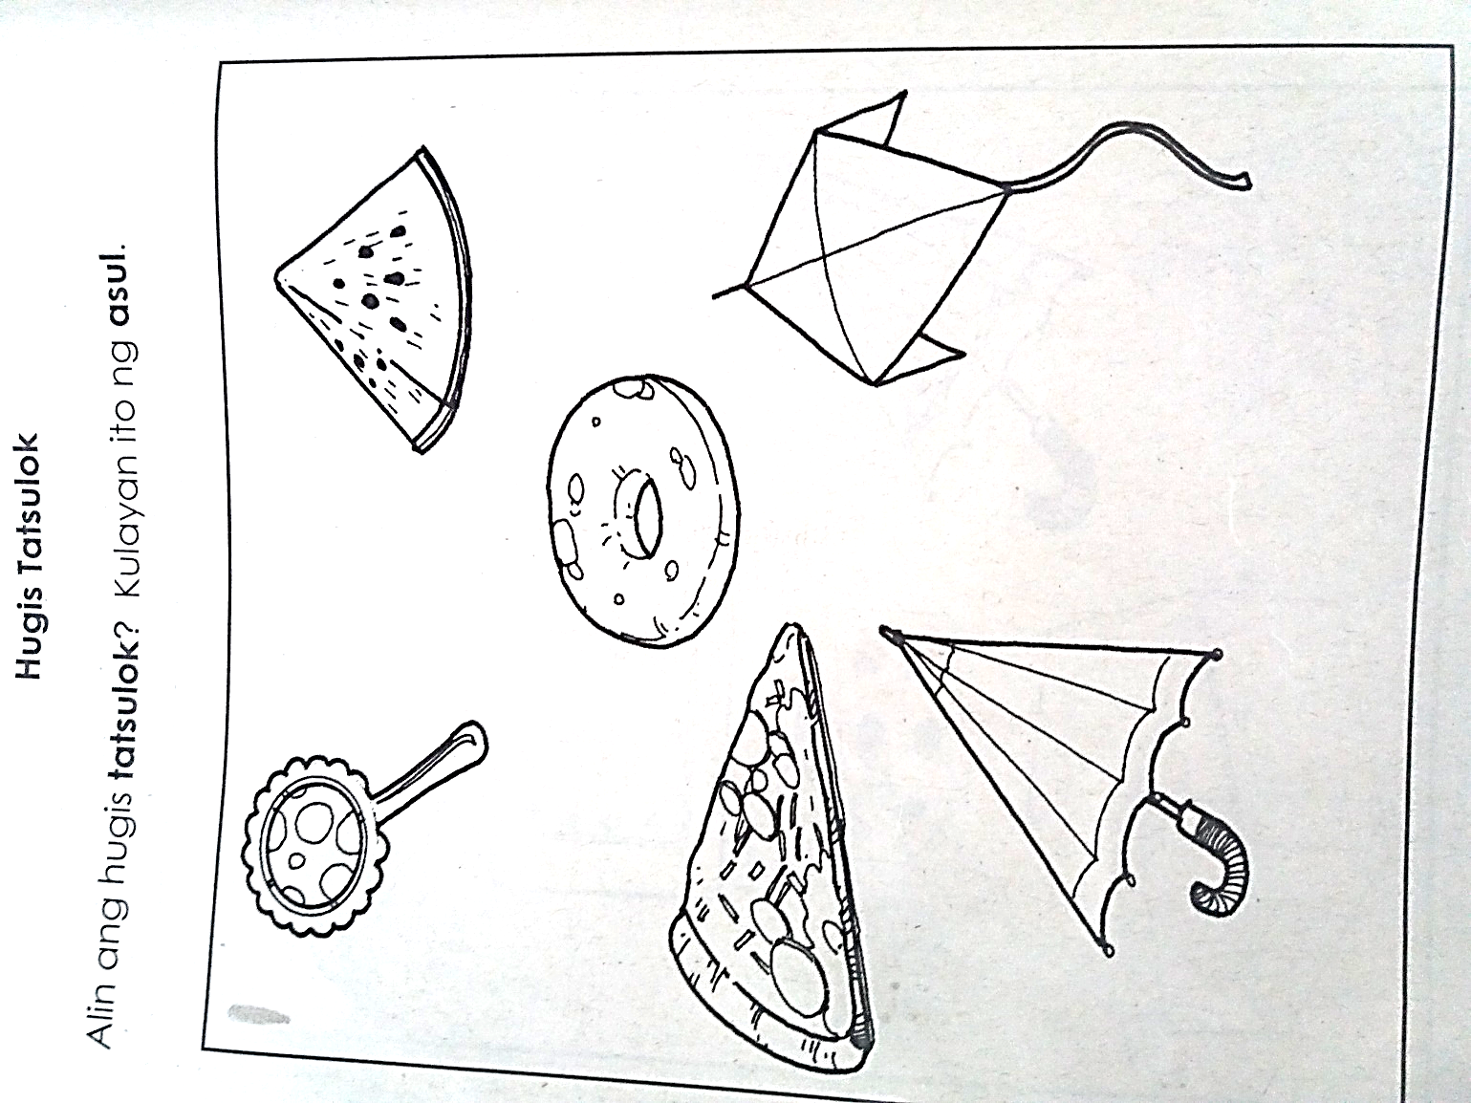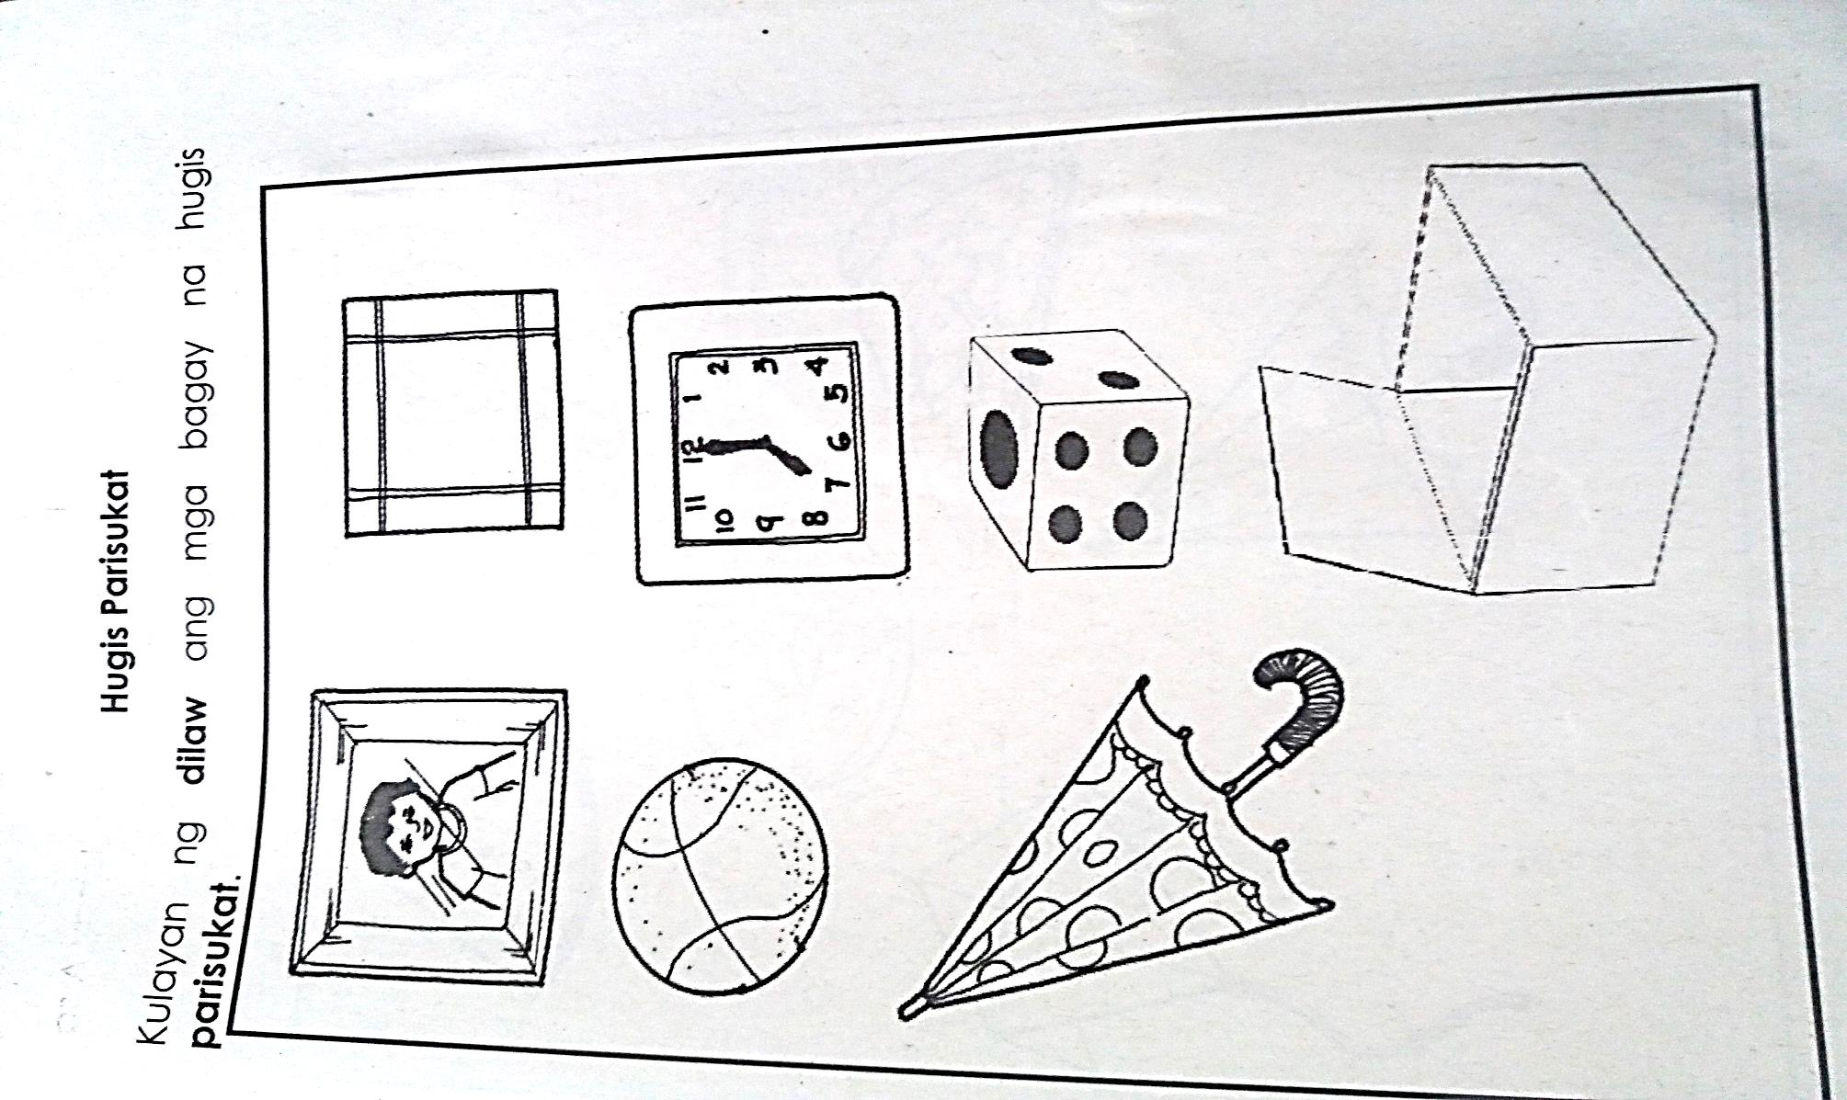

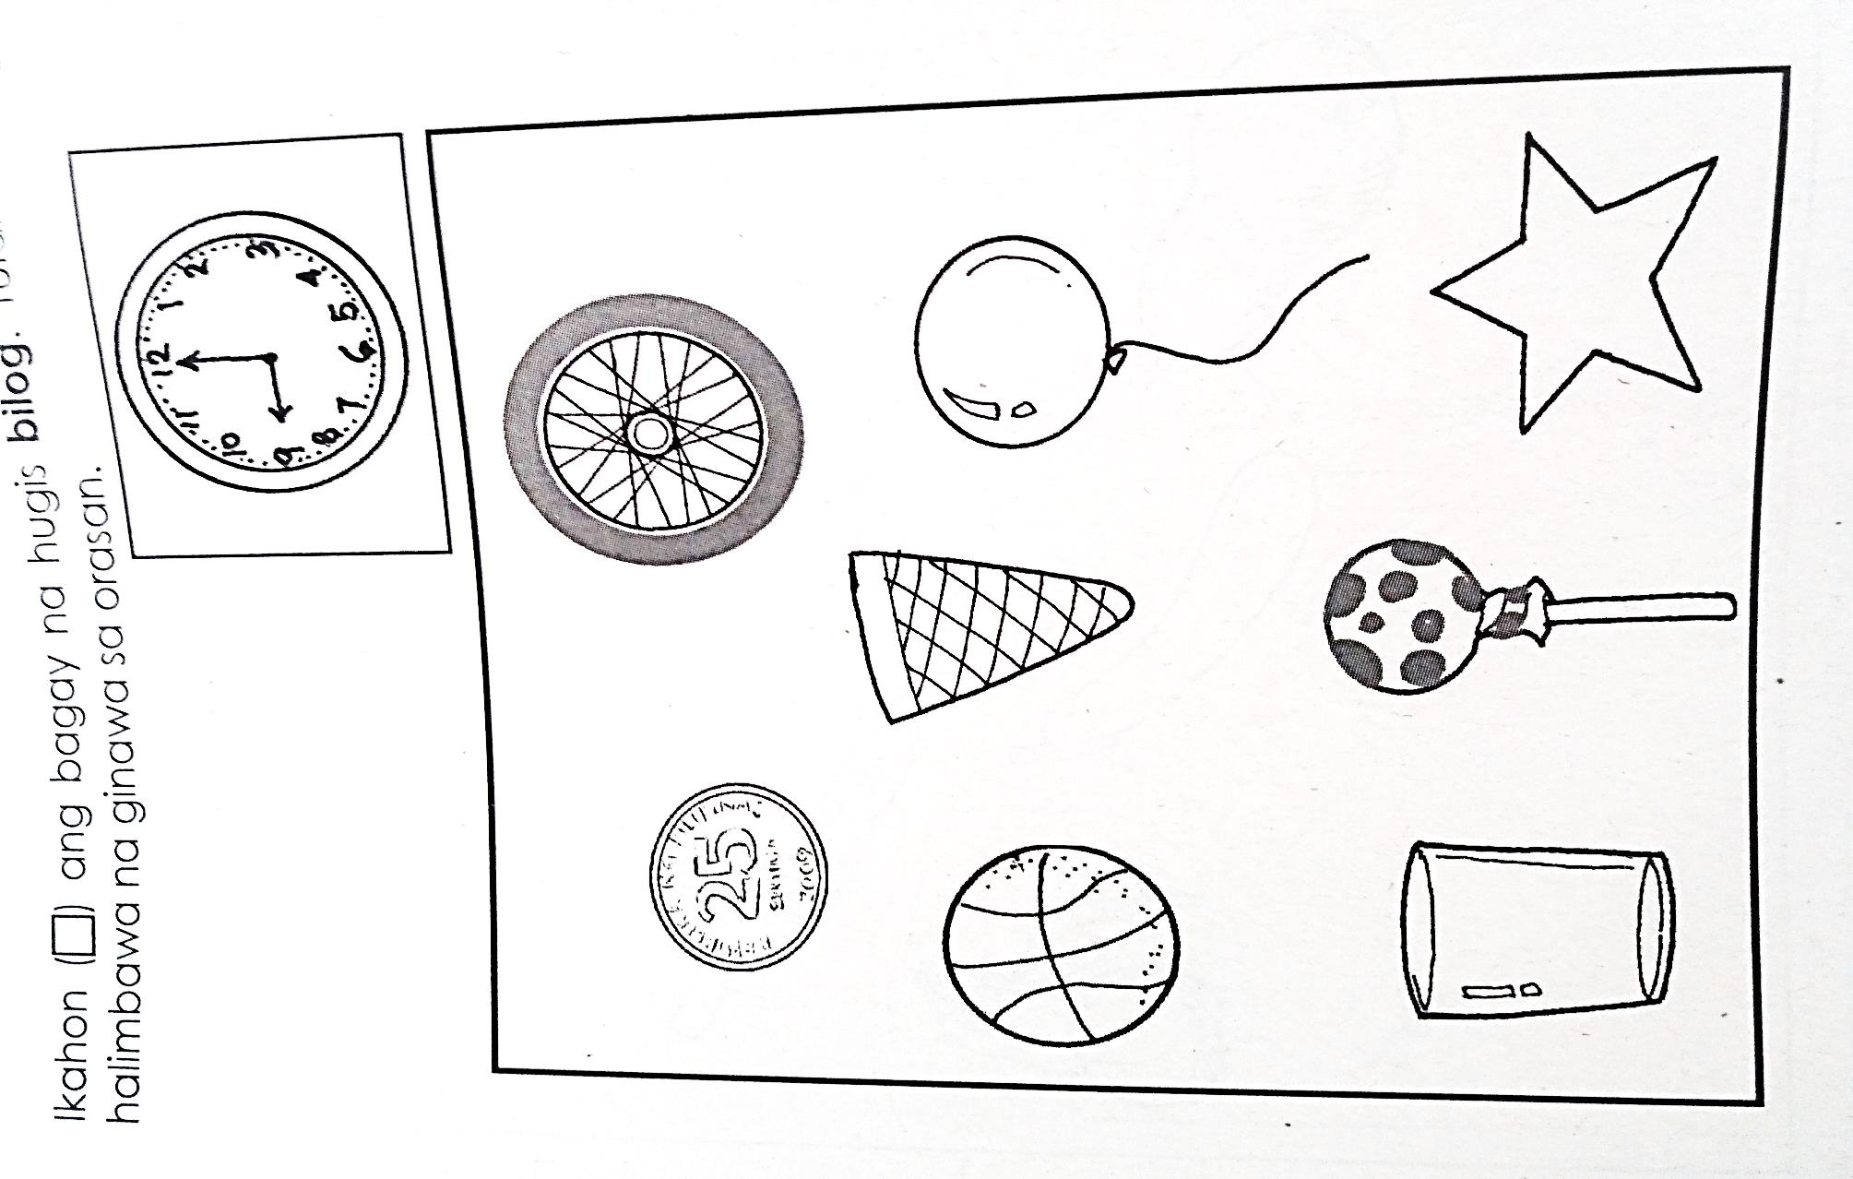

**Isulat ang tamang bilang ng bawat larawan. Piliin ang tamang bilang sa**

**loob ng kahon.**

**1 2 3**

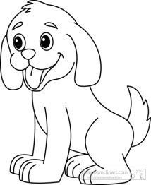

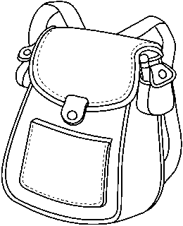



**Kulayan ang pangkat na mas marami**

|  |  |
| --- | --- |
| http://images.clipartpanda.com/mango-clipart-mango1.jpghttp://images.clipartpanda.com/mango-clipart-mango1.jpghttp://images.clipartpanda.com/mango-clipart-mango1.jpg  http://images.clipartpanda.com/mango-clipart-mango1.jpghttp://images.clipartpanda.com/mango-clipart-mango1.jpg | **http://images.clipartpanda.com/mango-clipart-mango1.jpghttp://images.clipartpanda.com/mango-clipart-mango1.jpghttp://images.clipartpanda.com/mango-clipart-mango1.jpg** |
| http://images.clipartpanda.com/closed-book-clipart-black-and-white-book-hi.pnghttp://images.clipartpanda.com/closed-book-clipart-black-and-white-book-hi.png | **http://images.clipartpanda.com/closed-book-clipart-black-and-white-book-hi.pnghttp://images.clipartpanda.com/closed-book-clipart-black-and-white-book-hi.pnghttp://images.clipartpanda.com/closed-book-clipart-black-and-white-book-hi.png** |

**SENSORY-PERCEPTUAL**

**Box the sense organ you used for each activity/object**.

|  |  |
| --- | --- |
| lollipop | **C:\Users\arjay1209\Downloads\Shareit\Photo\20160102_163306.jpgC:\Users\arjay1209\Downloads\Shareit\Photo\20160102_163306.jpgC:\Users\arjay1209\Downloads\Shareit\Photo\20160102_163306.jpg** |
| http://www.clipartkid.com/images/355/cute-clip-art-of-kids-reading-kids-color-free-kids-reading-clipart-Qgxin8-clipart.jpg  **C:\Users\arjay1209\Downloads\Shareit\Photo\20160102_163306.jpg** | https://encrypted-tbn3.gstatic.com/images?q=tbn:ANd9GcQPD29KE78MxcvkpQtGvwMhWXUoXqGuiaAgwgDBDKEjzJGBIdmWhttps://encrypted-tbn3.gstatic.com/images?q=tbn:ANd9GcQPD29KE78MxcvkpQtGvwMhWXUoXqGuiaAgwgDBDKEjzJGBIdmW**C:\Users\arjay1209\Downloads\Shareit\Photo\20160102_163306.jpgC:\Users\arjay1209\Downloads\Shareit\Photo\20160102_163306.jpg** |
| **C:\Users\arjay1209\Downloads\Shareit\Photo\20160102_163306.jpg** | **C:\Users\arjay1209\Downloads\Shareit\Photo\20160102_163306.jpgC:\Users\arjay1209\Downloads\Shareit\Photo\20160102_163306.jpg**https://encrypted-tbn3.gstatic.com/images?q=tbn:ANd9GcQPD29KE78MxcvkpQtGvwMhWXUoXqGuiaAgwgDBDKEjzJGBIdmWhttps://encrypted-tbn3.gstatic.com/images?q=tbn:ANd9GcQPD29KE78MxcvkpQtGvwMhWXUoXqGuiaAgwgDBDKEjzJGBIdmW |
|  | **C:\Users\arjay1209\Downloads\Shareit\Photo\20160102_163306.jpgC:\Users\arjay1209\Downloads\Shareit\Photo\20160102_163306.jpgC:\Users\arjay1209\Downloads\Shareit\Photo\20160102_163306.jpgC:\Users\arjay1209\Downloads\Shareit\Photo\20160102_163306.jpg** |
| http://classroomclipart.com/images/gallery/Clipart/Black_and_White_Clipart/Children/black-white-boy-drawing-clipart.jpg | https://encrypted-tbn3.gstatic.com/images?q=tbn:ANd9GcQPD29KE78MxcvkpQtGvwMhWXUoXqGuiaAgwgDBDKEjzJGBIdmWhttps://encrypted-tbn3.gstatic.com/images?q=tbn:ANd9GcQPD29KE78MxcvkpQtGvwMhWXUoXqGuiaAgwgDBDKEjzJGBIdmW**C:\Users\arjay1209\Downloads\Shareit\Photo\20160102_163306.jpg** |

**Check ( / ) the objectp that produces soft sound. Cross out ( X ) the**

**object that produces loud sound.**

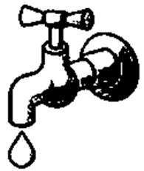

**Color the correct picture according to what taste the teacher will tell.**

|  |  |
| --- | --- |
| **sour** | http://clipartsign.com/upload/2016/01/27/clip-art-black-and-white-food-lemon-citron-black-white-line-art.jpghttp://www.clipartkid.com/images/249/ice-cream-clipart-black-and-white-clipart-panda-free-clipart-4X1PVo-clipart.gif |
| **salty** | http://www.clipartkid.com/images/84/salt-20clipart-clipart-panda-free-clipart-images-ZTFErB-clipart.png    coffee-clip-art-9TR5gzyTe |
| **bitter** | http://4.bp.blogspot.com/-LsJCZ0RETYw/UHmrrxvi6RI/AAAAAAAAAbk/PYuHroWhDCU/s1600/bitter%20melon.jpghttp://www.clipartkid.com/images/574/candy-corn-clip-art-black-and-white-clipart-panda-free-clipart-egNACN-clipart.gif  http://www.clker.com/cliparts/1/I/M/E/X/P/lollipop-clip-art-hi.png |
| **sweet** | http://previews.123rf.com/images/tribalium123/tribalium1231210/tribalium123121000059/15594641-Fried-Chicken-Drumstick-Stock-Vector-cartoon.jpg |

**Box the rough object and cross-out (x) the smooth one.**

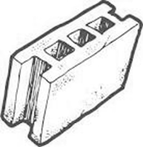

**Color the hot food (red) and (blue) for the cold one.**

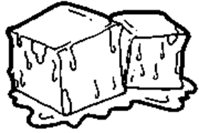

**Match the object to where it is use.**

**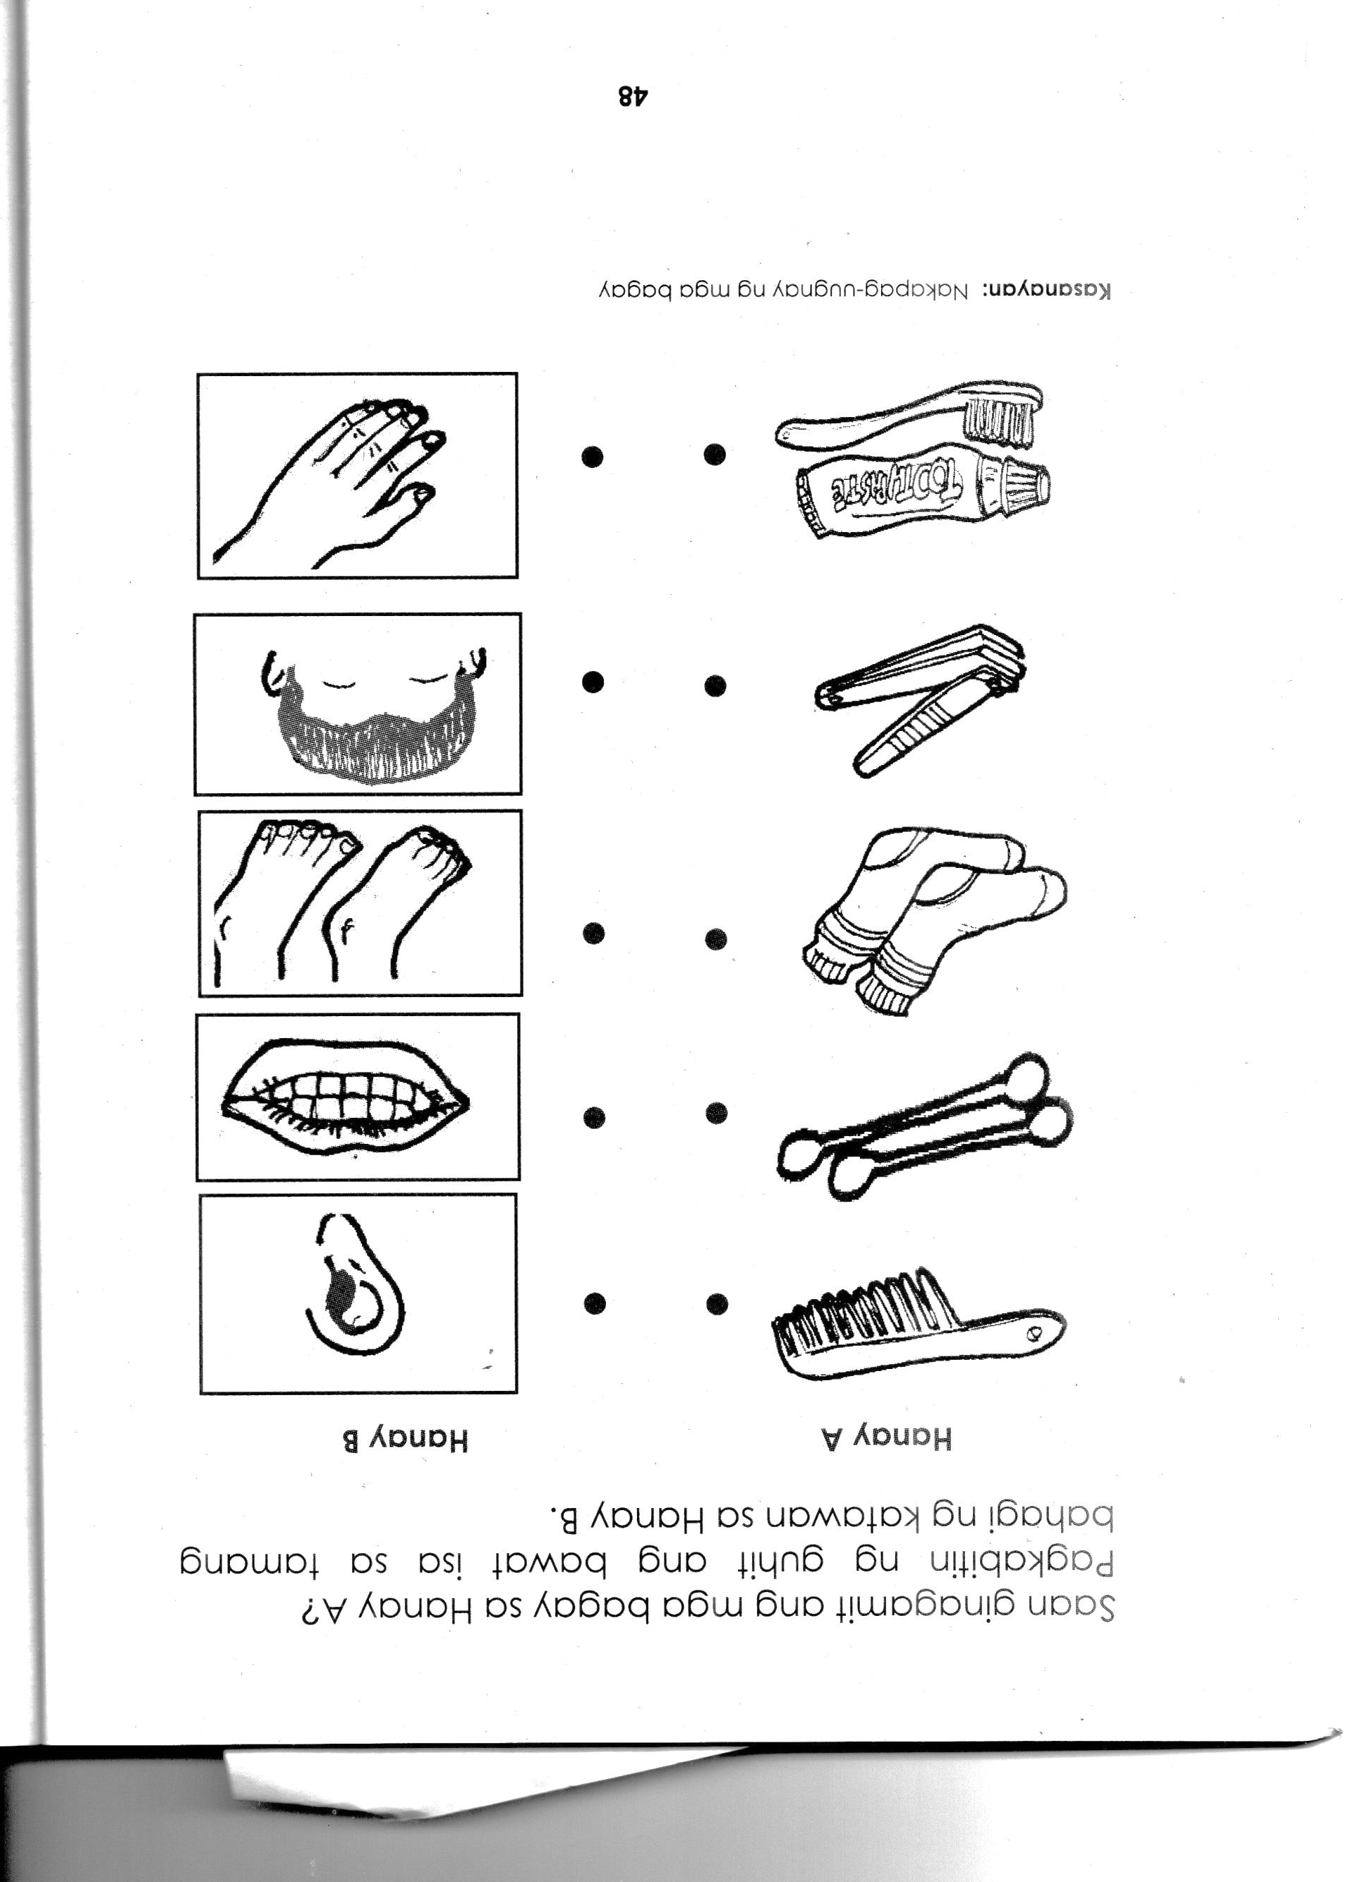**



**Department of Education**

**Region III**

**Schools Division of Zambales**

**District of Palauig**

**LIPAY ELEMENTARY SCHOOL**

**FIRST QUARTERLY ASSESSMENT**

**Kindergarten**

**Name: \_\_\_\_\_\_\_\_\_\_\_\_\_\_\_\_\_\_\_\_\_\_\_\_\_\_\_\_\_\_\_\_\_ Score:\_\_\_\_\_\_\_\_\_\_\_\_\_\_**

**Section: \_\_\_\_\_\_\_\_\_\_\_\_\_\_\_\_\_\_\_\_\_\_\_\_\_\_\_\_\_\_\_\_ Date:\_\_\_\_\_\_\_\_\_\_\_\_\_\_\_**

|  |  |  |
| --- | --- | --- |
| **SUBJECT** | **ITEM** | **SCORE** |
| **Language** | **10** |  |
| **Filipino** | **10** |  |
| **Numeracy** | **10** |  |
| **Sensory-Perceptual** | **20** |  |
| **TOTAL** | **50** |  |

**Prepared by:**

**ARJAY S. FARIÑAS**

**Adviser**

***“Train up a child in the way he should go; and when he is old,***

***he will depart from it.”***

***Proverbs 22:6***