Daily Lesson Log | School |  | Grade Level | VI
 | Teacher |  | Learning Area | MAPEH
 | Teaching Week & Dates/Time |  | Quarter | I

DATE:
 | MONDAY | TUESDAY | WEDNESDAY | THURSDAY | FRIDAY
I. OBJECTIVE/S | MUSIC | ARTS | P.E. | HEALTH
- Content Standard | demonstrates understanding  of the concept of rhythm by  applying notes and rests,  rhythmic patterns, and time  signatures | Demonstrates  understanding of the  use of lines, shapes,  colors, texture, and the  principles of emphasis  and contrast in drawing  a logo and own cartoon  character using new  technologies in drawing. | demonstrates understanding of  participation and assessment of physical activity and physical  fitness | Demonstrates understanding of  personal health issues and  concerns and the importance of health appraisal procedures and community resources in  preventing or managing them | demonstrates understanding  of the concept of rhythm by  applying notes and rests,  rhythmic patterns, and time  signatures
- Performance Standard | responds to beats in  music heard with  appropriate  conducting patterns of  2 3 4 and 6  4 4 4 8 | Creates concepts through art  processes, elements, and  principles using new  technologies (hardware and  software) to create personal  or class logo.  designs cartoon character onthe spot using new  technologies | participates and  assesses performance  in physical activities.  assesses physical  fitness | practices selfmanagement  skills to prevent and control  personal health issues and  concerns | responds to beats in  music heard with  appropriate  conducting patterns of  2 3 4 and 6  4 4 4 8
- Learning Competencies  (write the LC Code) | identifies the notes / rests  used in a particular song  2 3 4  4 4 4 time signatures  MU6RH-Ia-1 | Realizes that art processes,  elements and principles still  apply even with the use of  new technologies.  A6EL-Ia  2. Appreciates the elements  and principles applied in  commercial art.  A6PL-Ia | 1. describes the Philippines  physical activity pyramid  PE6PF-Ia-16  2. explains the indicators  for fitness  PE6PF-Ia-17  3. explains health and skill  related fitness components  PE6PF-Ia-21 | describes personal  health issues and  concerns  H6PHIab-18  demonstrates selfmanagement skills  H6PHIab-19 | identifies the notes / rests  used in a particular song  6  8 time signature  MU6RH-Ia-1
II. CONTENT | RHYTHM  Musical Symbols and  Concepts:  1. Notes and Rests | Elements:  1. LINE  2. SHAPE  3. COLOR  4. TEXTURE  5. producing these using  technology | Assessment of physical  activities and physical fitness | Personal Health -Issues and  Concerns  1. height and weight(stunted  growth, underweight,  overweight, obesity)  2. hearing (impacted cerumen,  swimmer’s ear, otitis media)  3. vision  4. (astigmatism, myopia,  hyperopia,xerophthalmia,  strabismus)  5. skin, hair andand nail  6. (sunburn, dandruff ,corns,  blisters and calluses, ingrown  toenails)  7. posture and spine disorders  (scoliosis, lordosis, kyphosis)  8. oral/dental problems  (cavities, gingivitis,  periodontitis, malocclusion,  halitosis) | RHYTHM  Musical Symbols and  Concepts:  1. Notes and Rests
III. LEARNING RESOURCES
- References
- TG/CG pages
- Learner’s Materials pages
- Textbook pages | MISOSA4-Module6  MISOSA5-module1  *Musika at Sining  6. Sunico, Raul  M. et al, 2000.  pp.8-10  *Umawit at  Gumuhit 6.  Valdecantos,  Emelita C. 1999.  pp.5-16, pp.25-26 |  | 21st Century MAPEH in ACTION  By Gerardo C. Lacia et.al  Copyright ,2016 pp.118-125 | OHSP Health 1 Q1 Module 1, Reading 2  2. OHSP Health 1 Q2 Module 1 pp.10-13  3. EdukasyongPangkatawan, kalusugan, at  Musika I. DepED. Abejo, Mary Placid Sr.  et.al. 1991.pp.46-52, 69-76  Science and Health for the Better Life 5.  IMDC-DepED.PRODED. Abracia,  Norma,et.al.1995. pp.49  2. EdukasyongPangkatawan,Kalusugan,at  Musika I. DepED. Abejo, Mary Placid Sr. et.  al. 1991. pp.62-64;72-80 | MISOSA4-Module6  MISOSA5-module1  *Musika at Sining  6. Sunico, Raul  M. et al, 2000.  pp.8-10  *Umawit at  Gumuhit 6.  Valdecantos,  Emelita C. 1999.  pp.5-16, pp.25- 26
- Materials downloaded from LRMDS
- Other Learning Materials |  | Laptop, digital art works, sample of commercial arts downloaded from the net | Laptop, projector
IV. PROCEDURES
- Reviewing previous lesson and presenting new lesson | Let the pupils sing the Welcome Song  Sing the song Tao, taopo  Clap the beat of the song | Review the basic terminologies in arts  What are the elements of arts? Principles ?processes ? | Can you still recall your lesson about the Physical activity pyramid ? | What lessons in Health 5 that you can still remember ?
- Establishing a purpose for the lesson | Today, we are going to identify the notes and rest in a song that we’re going to learn | After the session,you are going to realize that art processes,  elements and principles still  apply even with the use of  new technologies. | Today, you are going to describe the Philippine physical activity pyramid | In our lesson you will describe personal health issues and  Concerns and  Demonstrate self management skills
- Presenting examples/instances of the lesson | Play the music chicken dance. Let the pupils dance with the music  Present the song Haranasabukid. Teach the song  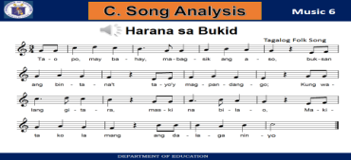 | Present sample of commercial arts  Help/ Guide the students describe, interpret, evaluate, theorize and judge the properties and qualities of the visual form, for the purpose of understanding and appreciating works of art and understanding the roles of art in society.  ART HISTORY  Attribution  Where, when, why, and by whom was an artwork made?  Style  Style refers to the distinguishing characteristics of a work of art that identify it as typical of an individual artist, culture, school, movement, or time period. Artworks may exhibit personal, national, and/or period styles. | How would you describe the Philippine physical activity pyramid ?  Show the illustration of the Phil Physical activity pyramid  What activities are found in STEP 1 ? STEP 2? STEP 3 ?STEP 4 ?  What are the aims of the physical activity pyramid?  Why are physical activities important ? | What are the common health issues that you have or you have observe ?  Assign these topics to small groups for them to discuss and the report to the class  1. height and weight(stunted  growth, underweight,  overweight, obesity)  2. hearing (impacted cerumen,  swimmer’s ear, otitis media)  3. vision  4. (astigmatism, myopia,  hyperopia,xerophthalmia,  strabismus) | Teach the song.  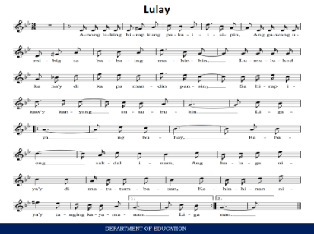  Analyze the song`  What is the title of the song?  What is the time signature of the song? What does it mean by the upper number in the time signature? The second number ? What are the notes and rest you found in the song ?
- Discussing new concepts and practicing new skills #1 | Analyze the song.  What is the time signature of the song ? What does the upper number in the time signature mean? How about the lower number ? What are the notes and rests you find in the song ?( quarter note) (eight note) (quarter note ) ( half note ) . (dotted quarter note )  What does it mean by the song ? Discuss the value of the song in relation to the culture of Filipinos | Group Discussion on theff:  ART CRITICISM  Guide Questions for art criticism  Description: What do I see? (feel, hear, smell, taste)?  •Subject Matter: Does the artwork depict anything? If so, what?  •Medium: What tools, materials, or processes did the art make use?  •Form: What elements did the maker choose and how did the  maker organize the elements?  *Interpretation: What is the artwork about?  •Interpretive Statement: Can I express what I think the artwork is about in one sentence? | What are the indicators or signs of physical fitness ?  Do you like doing physical activities ?  Can you stretch your muscles w/o feeling discomfort or pain?  Can you move your body with a little or no difficulty?  Can you run 1.6 km in eight minutes with ease ?  Is the amount of your fat less than your weight of lean muscles bones and body organs ?  If yes, you are physically fit. If your answers are no, you have to work out for your physical fitness | Big group sharing  What are these? How do you handle these | Emphasize the discussion of the meaning of the song
 | MONDAY | TUESDAY | WEDNESDAY | THURSDAY | FRIDAY
- Discussing new concepts and practicing new skills #2 | Help the students analyze the song  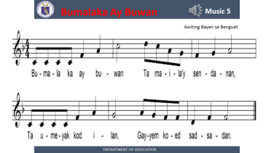  What is the time signature of the song ?What does the numbers in the time signature mean ? What are the notes and rests in the song? | Evidence: What evidence inside or outside the artwork supports my interpretation?  Judgment: Is it a good artwork?  Criteria: What criteria do I think are most appropriate for judging the artwork?  Evidence: What evidence inside or outside the artwork relates to each criterion?  Judgment: Based on the criteria and evidence, what is my judgment about the quality of the artwork? | Group the class in three.  Group 1 -Ask them to work on the following topics  What are the four signs of fitness ? ( endurance,flexibility,strength,body composition )  Group 2- What are the health-related fitness components  Group 3- What are the skill-related fitness components. ( cardio-vascular fitness, healthful composition, flexibility, muscular strength, muscular endurance )  ( The pupils will recall their lessons in Grade 4 or they will research. They can use the Grade 4 LM for this activity ( agility,balance,coordination, reaction time,speed, power ) |  | Present the musical score of the song “HimigPasko “  Help the pupils identify the notes and rests in the song  ( Any folk song with 6  8  Time signature may be used )
- Developing mastery (lead to formative assessment 3) | Let the pupils draw and identify the notes in the song |  | Group reporting/ presentation |  | Flash different notes and rests, and let the pupils identify them
- Finding practical application of concepts and skills in daily living | Present another song with 2  4 time signature and ask the pupils to identify the different notes and rest found in the song. This activity may be done by group | Are the elements and principles of arts present in the art work ? |  | Practice selfmanagement  skills to prevent and control  personal health issues and  concerns
- Making generalization and abstractions about the lesson | 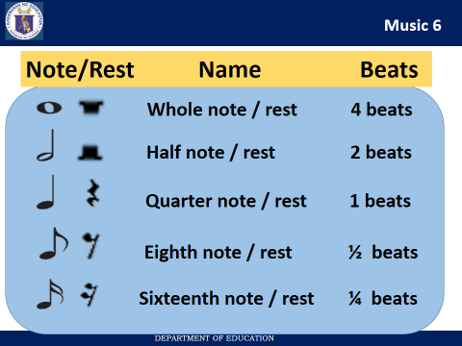 | What is the art processes in this art work? What elements of art are present ?principles ?
- Evaluating learning | 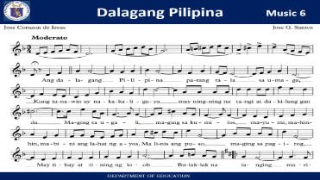  Identify the notes and rests found in the song | Self assessment  1.Whatdid I do in my art class today ?  2.What did I learn ?  3.What did I find interesting about the art?  4.What questions do I have about what I learned  5.What was the point of today’s lesson ? | Ask the following questions. Pupils may answer these either by writing drawing or performing/role play  - Describe the Philippine activity pyramid  - What are the indicators for fitness ?  - What do you mean by cardio-vascular fitness ?  - What do you mean by agility  - What is meant by speed ? | Do you practice personal hygiene to prevent and control personal health concerns.? What are these ? | Identify the notes and rests found in the song  ( Present a copy of a musical score of any folksong in the six-eight time signature )
- Additional activities for application or remediation
V. REMARKS
VI. REFLECTION | Assessing yourself as a teacher and analyzing the students’ progress this week.
- No. of learners who earned 80% in the evaluation
- No. of learners who acquired additional activities for remediation who scored below 80%
- Did the remedial lessons work? No. of learners who have caught up with the lesson.
- No. of learners who continue to require remediation.
- Which of my teaching strategies worked well? Why did these work?
- What difficulties did I encountered which my principal can help me solve?
- What innovation or localized materials did I used/discover which I wish to share with other teachers?

PREPARED BY:
EVELYN M. CABAHUG
MT- I
ABONGAN ELEMENTARY SCHOOL
TAYTAY DISTRICT II

LILIAN A. SAN JOSE
PSDS TAYTAY I
CONSULTANT

