Daily Lesson Log | School |  | Grade Level | VI
 | Teacher |  | Learning Area | MAPEH
 | Teaching Week & Dates/Time |  | Quarter | I

DATE:
 | MONDAY | TUESDAY | WEDNESDAY | THURSDAY | FRIDAY
I. OBJECTIVE/S
- Content Standard |  | demonstrates understanding  of the concept of rhythm by  applying notes and rests,  rhythmic patterns, and time  signatures | demonstrates  understanding of the  use of lines, shapes,  colors, texture, and the  principles of emphasis  and contrast in drawing  a logo and own cartoon  character using new  technologies in drawing | demonstrates understanding of  participation and assessment of physical activity and physical  fitness | The learner…Demonstrates  understanding of personal health issues and  concerns and the importance of health appraisal procedures and community resources in  preventing or managing them
- Performance Standard |  | responds to beats in  music heard with  appropriate  conducting patterns of  2 3 4 and 6  4 4 4 8 | creates concepts through art  processes, elements, and  principles using new  technologies (hardware and  software) to create personal  or class logo.  designs cartoon character onthe spot using new  technologies | participates and assesses performance in physical activities assesses physical  fitness | practices selfmanagement  skills to prevent and control  personal health issues and  concern
- Learning Competencies  (write the LC Code) |  | Differentiates among 2 3 4  4 4 4  And 6 time signatures  8  •Describes the4  4 time signature  MU6RH-Id-e-2 | creates personal or class  logo as visual  representation that can be  used as a product, brand,  ortrademark  A6PR-Id | 1`explains thenature/background of the games  PE6GS-Ib-1  2.describes the skills involved in the games  PE6GS-Ib-2  3.observes safety precautions  PE6GS-Ib-h-  4.recognizes the value of  participation in physical  activities  PE6PF-Ib-h-19  assesses regularly  participation in physical activities based on the  Philippines physical activity pyramid  PE6PF-Ib-h-18  5.displays joy of effort, respect for others and fair play during  participation in physical  activities  PE6PF-Ib-h-20  6.identifies areas for improvement  PE6PF-Ib-h-22 | explains the importance of  undergoing health appraisal procedure  H6PH-Idf-21  regularly undergoes  health appraisal  procedures  H6PH-Idf-22
II. CONTENT |  | RHYTHM  Musical Symbols and  Concepts:  1. Notes and Rests  2. Meters  3. Rhythmic Patterns | Process:  8. DRAWING – NEW  TECHNOLOGIES  8.1 logo  8.2 cartoon characters  LOGO DESIGN  Software: Inkscape (Open  Source) for Laptop/Desktop PC | Assessment of  physical  activities and  physical fitness  Target games  (Tatsing) | Undergoing Health Appraisal  Procedures (height and weight  measurement, breast selfexamination for girls, hearing  test, vision screening, scoliosis  test and health and dental  examinations)
III. LEARNING RESOURCES
- References
- TG/CG pages
- Learner’s Materials pages
- Textbook pages |  | MISOSA5-module6 Musika at Sining 6. Sunico, Raul  M. et al, 2000 |  | ASE P.E Module 2 pp.6-7,12-13  21st Century MAPEH in Action  Gerardo C. Lacia pp.  Copyright 2016,pp126 | OHSP Health 1Q1 Module 1 Reading 2 pp.  8-9 Screening test  2. EdukasyongPangkatawan,Kalusugan,at  Musika I. DepED. Abejo, Mary Placid Sr. et.  al. 1991. pp.49-50;54-59;69-71.
- Materials downloaded from LRMDS
- Other Learning Materials |  | Projector, laptop, musical scale of the songs HaranasaBukid, or any folk songs in three-four time signature  pp.8-10  *Umawit at Gumuhit 6.Valdecantos,  Emelita C. 1999. pp.5-20 | Desk top, laptop , graphing paper (alternative )
IV. PROCEDURES
- Reviewing previous lesson and presenting new lesson |  | Let the pupils sing the song “HARANA SA bUKID“. Ask the pupils to pass the ball following the rhythm of the song | Review the concepts on the use of software  Commands, menu etc.. | Review the previous lesson
- Establishing a purpose for the lesson |  | Today, we are going to describe the 4  4 time signature | Are you familiar with this art?  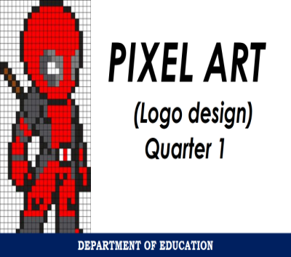  Today, we are going to create your own logo, using pixel art | Today you are going to play tatsing. Why Tatsing ?
- Presenting examples/instances of the lesson |  | Present the song Bumalaka ay Buwan  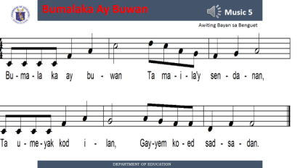  What is the time signature of the song ?WHAT is meant by the upper 4 ?, the lower 4 ?What are the notes and rests used in the song? What is the value of the quarter note/rest, eight note/rest , half note/rest ? How many beats are there in each measure of the song ? | Have a short discussion on the history and processes of pixel art  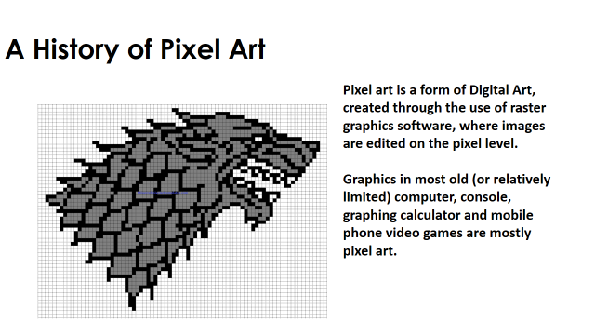  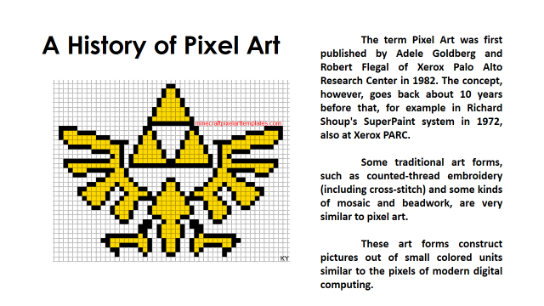 | Feel the pride of being a Filipino with Tatsing. This game promote healthful lifestyle. Furthermore,they promote: patriotism( to feel the pride of being Filipino) Bonding( to build bridge of fun and closeness among neighborhood to develop camaraderie with peers) and sportsmanship ( to build a positive outlook on acceptance of winning and being defeated
- Discussing new concepts and practicing new skills #1 |  | Help the students clap/ tap the rhythmic pattern of the song “Bumalaka ay Buwan “ | Remind the pupils of thw Dos and DONTs while making an art work.  Provide the class with graphing paper, in the absence of laptop or computer. Demonstrate to the pupils how to use the graphing paper in creating a logo | Make sure to remind the class of the precautionary measures while playing before you let them play the game. ( Those who cannot perform the game may serve as scorer or can play as sport journalist who will cover the game )
 | MONDAY | TUESDAY | WEDNESDAY | THURSDAY | FRIDAY
- Discussing new concepts and practicing new skills #2 |  | ( May use the rhythmic syllables to represent each note in the rhythmic pattern ) | Group activity  Help the pupils to do the art process. Students who are good in pixel art may assist their peers | Call a pupil to discuss the Mechanics of the game
- Developing mastery (lead to formative assessment 3) |  | Present the song  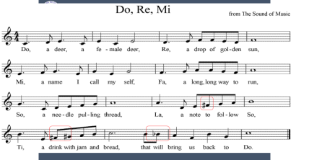 | ART PRODUCTION | Give emphasis on the value of the game. Make sure that the pupils will bear in mind that the game is never a way of teaching them to gamble but for them to be able to take pride of their culture while enjoying the game
- Finding practical application of concepts and skills in daily living |  | Group activity  - What is the time signature of the song?  - What are notes and rests used in the song?  - What is the value of notes/rests in the song?  - How many beats are there in each measure  Clap the rhythmic pattern of the song |  | ?
- Making generalization and abstractions about the lesson |  | How would you describe the 4  4  Time signature | What should we remember in making a logo using pixel art ? | What skills are develop in the game ?How would you assess your physical fitness after playing the game ?
- Evaluating learning |  | Use rubrics to assess the performance of the pupils | Rubrics  Process 50%  Product 50% | 1.Did you enjoy the game ?  2. Describe the skills involved in the game ?  3.Did you observe safety precautions ?  4. Did you display joy of effort, respect for others and  fair play during your participation to the game ?  5.Do you feel proud being Filipino while playing the game?
- Additional activities for application or remediation
V. REMARKS
VI. REFLECTION | Assessing yourself as a teacher and analyzing the students’ progress this week.
- No. of learners who earned 80% in the evaluation
- No. of learners who acquired additional activities for remediation who scored below 80%
- Did the remedial lessons work? No. of learners who have caught up with the lesson.
- No. of learners who continue to require remediation.
- Which of my teaching strategies worked well? Why did these work?
- What difficulties did I encountered which my principal can help me solve?
- What innovation or localized materials did I used/discover which I wish to share with other teachers?

EVELYN M. CABAHUG
MT – I
ABONGAN ELEMENTARY SCHOOL
TAYTAY DISTRICT

LILIAN A. SANJOSE
PSDS TAYTAY I
CONSULTANT

